DWDM LAB PROGRAMS

1)R-Program for Bar Plot

Program:

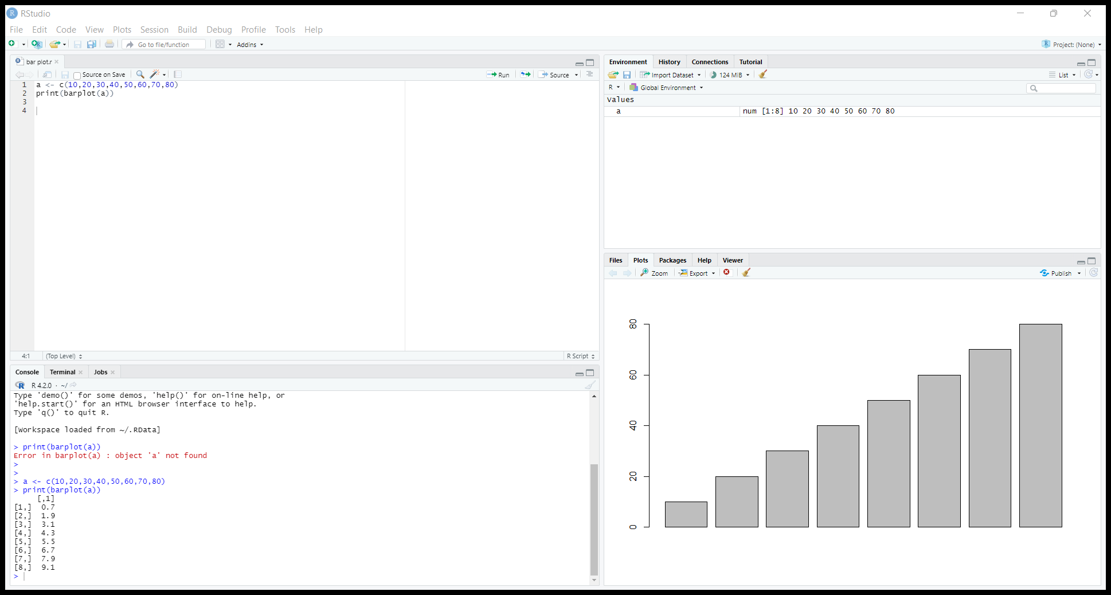

Out Put:

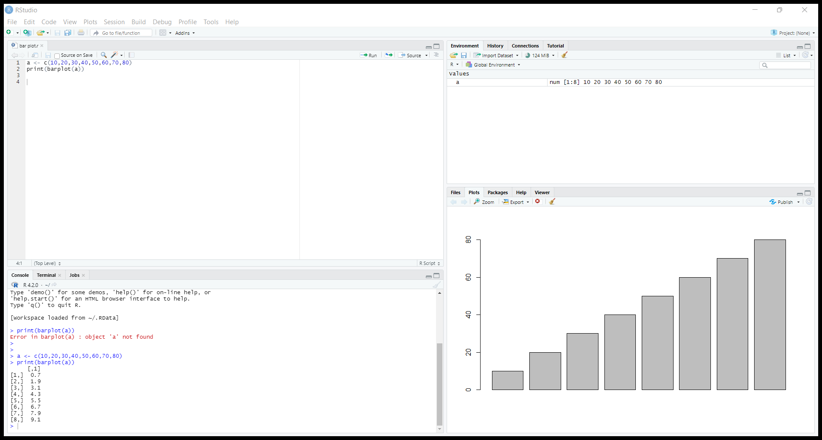

2)R-Program for Box plot:

Program:

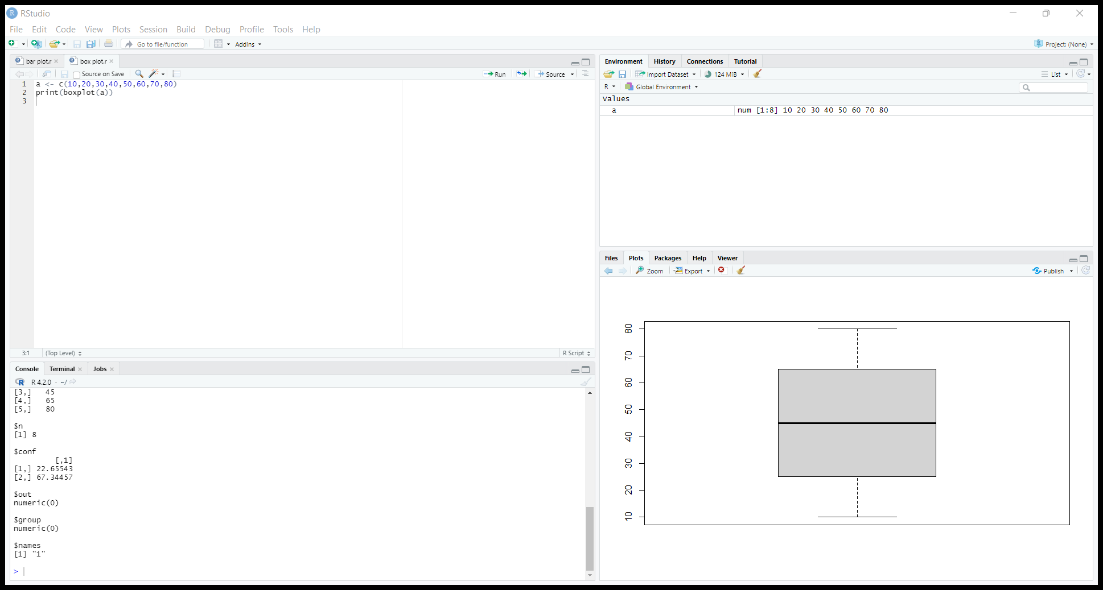

Output:

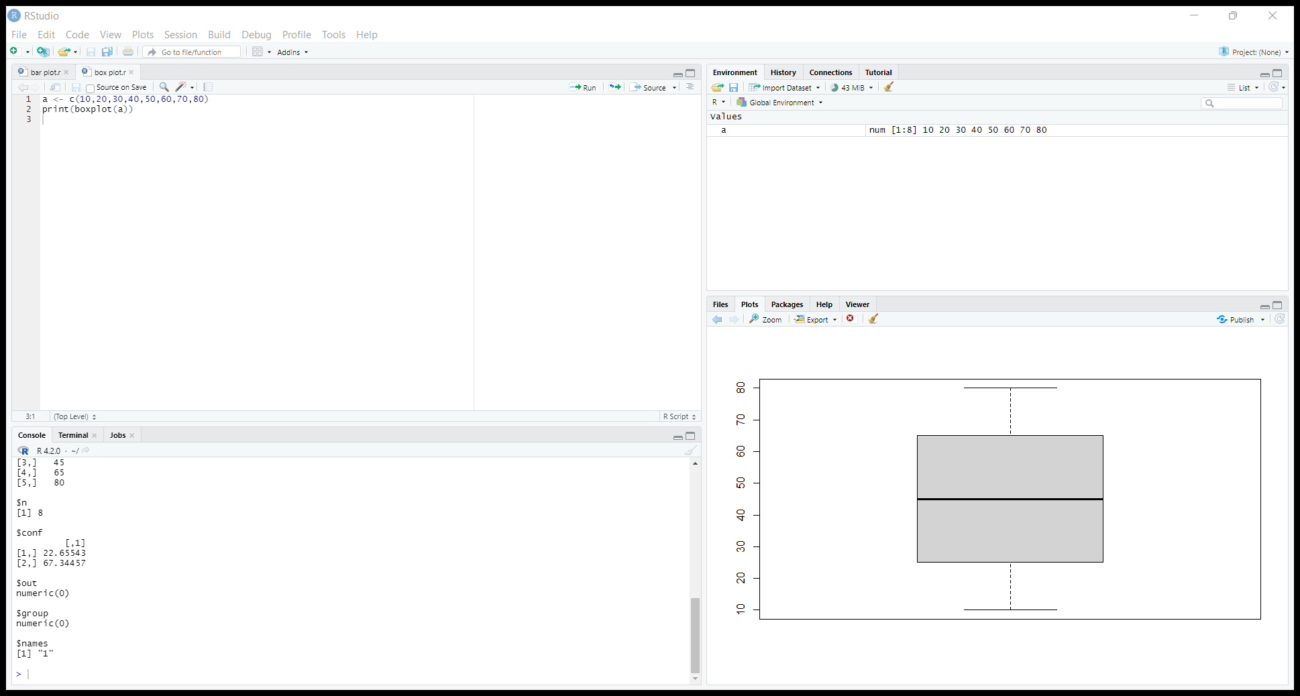

3)R-Program for Histogram Plot

Program:

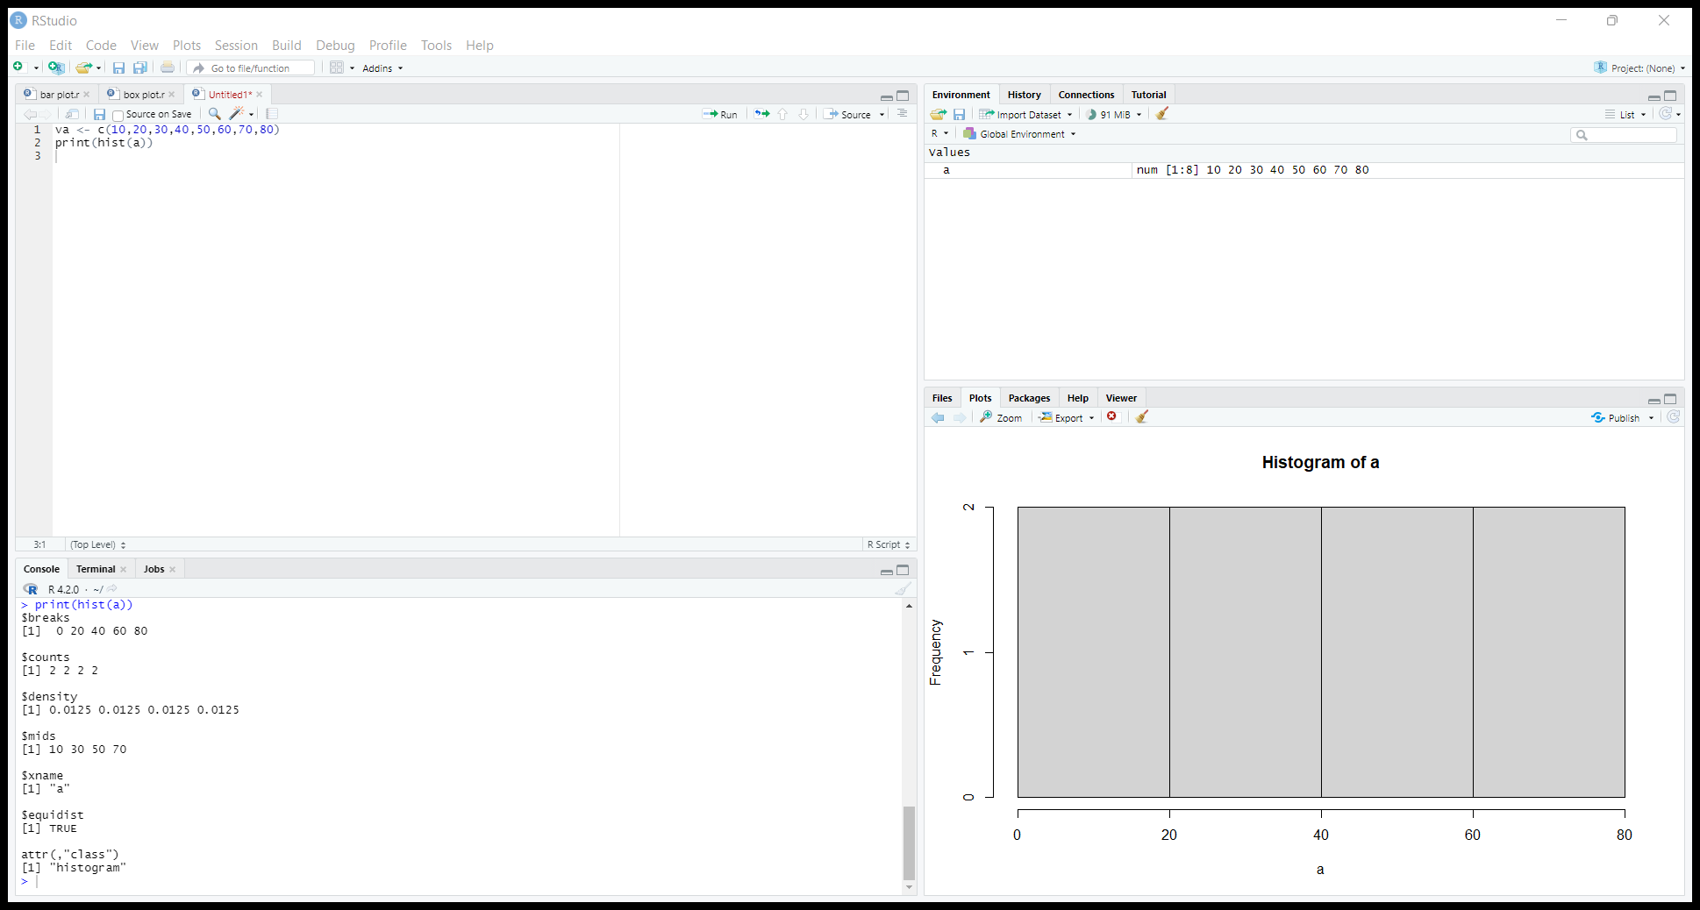

Output:

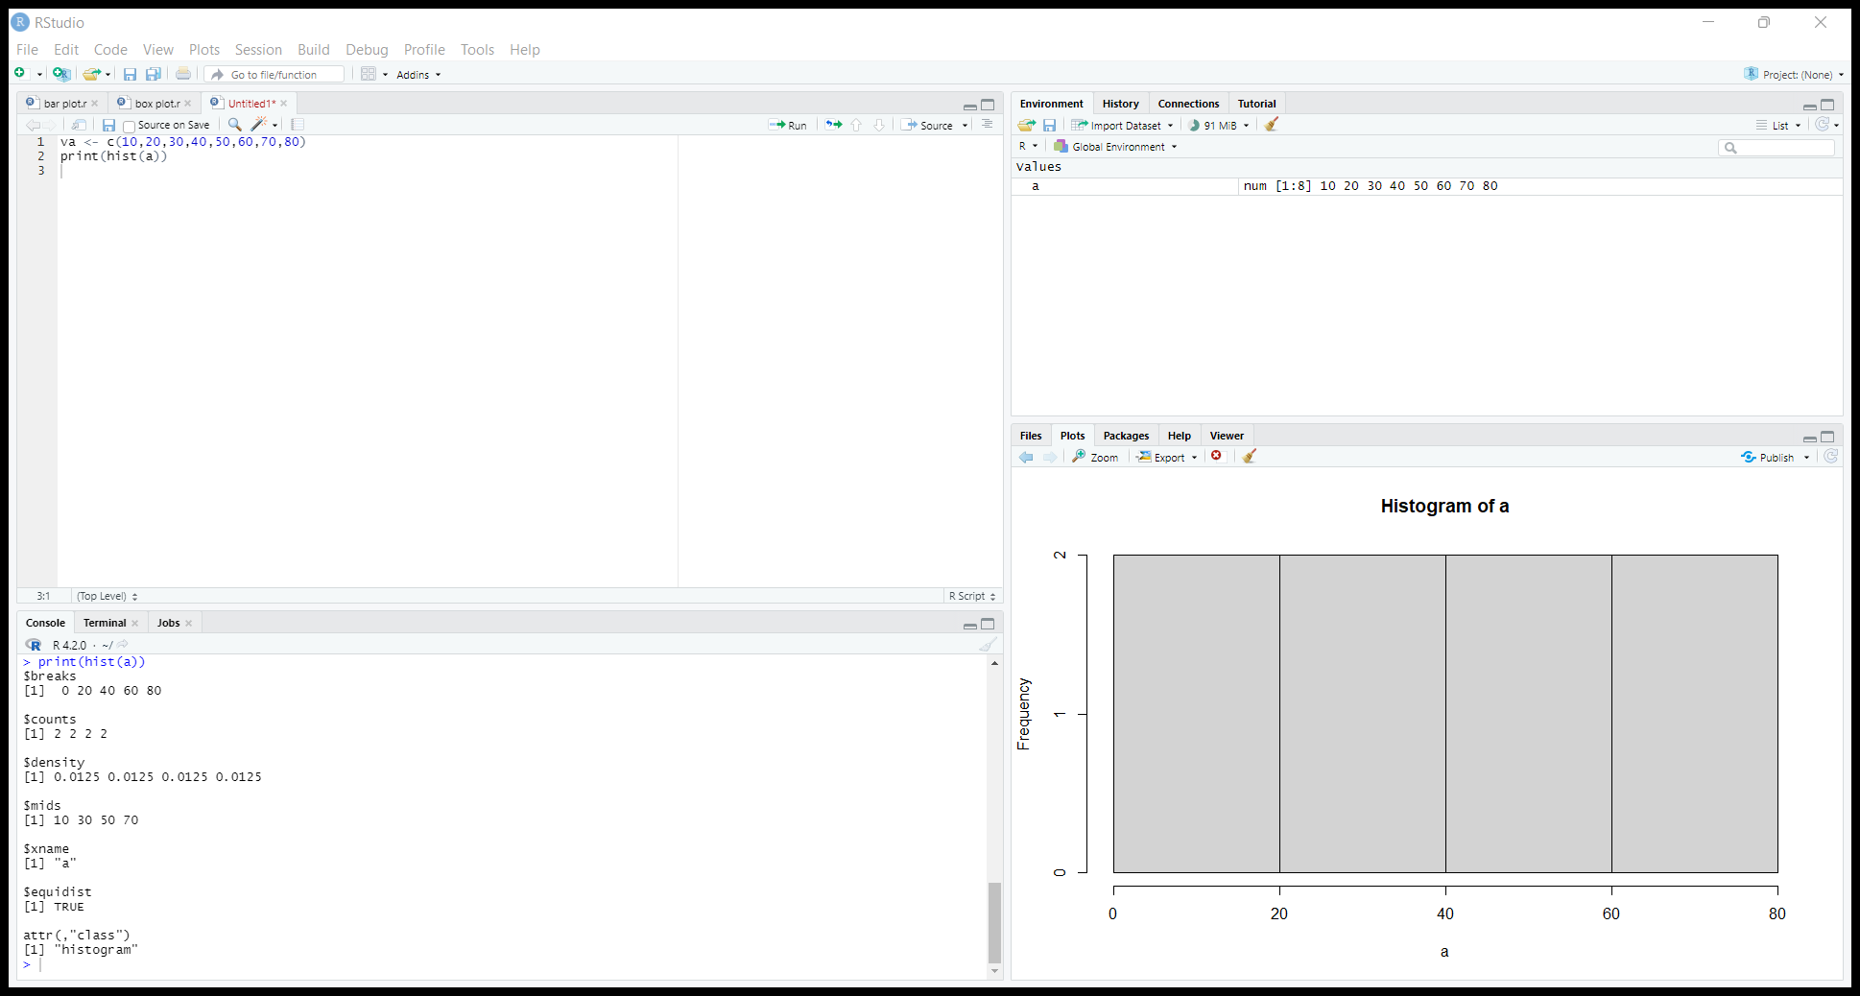

4)R-Program for Scatter Plot:

Program:

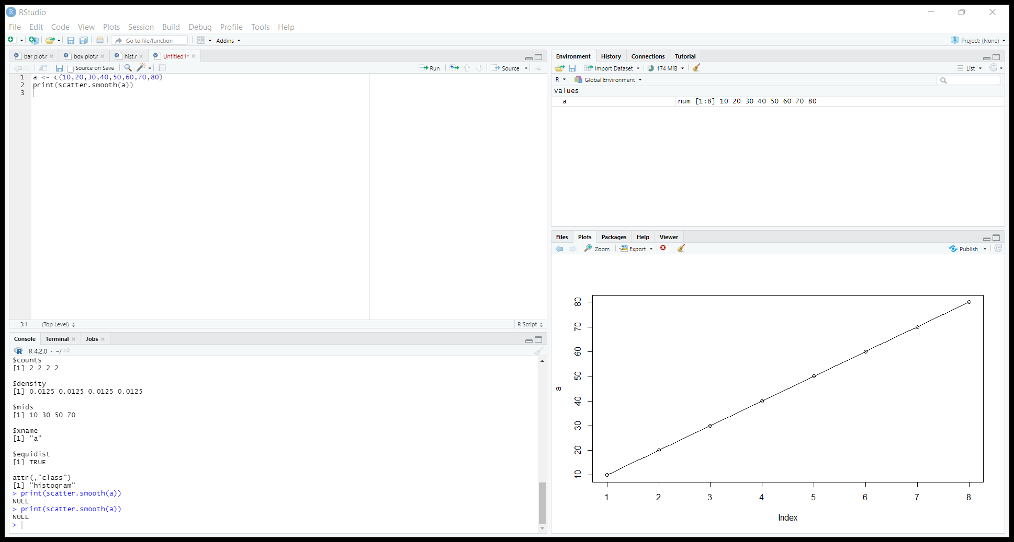

Out put:

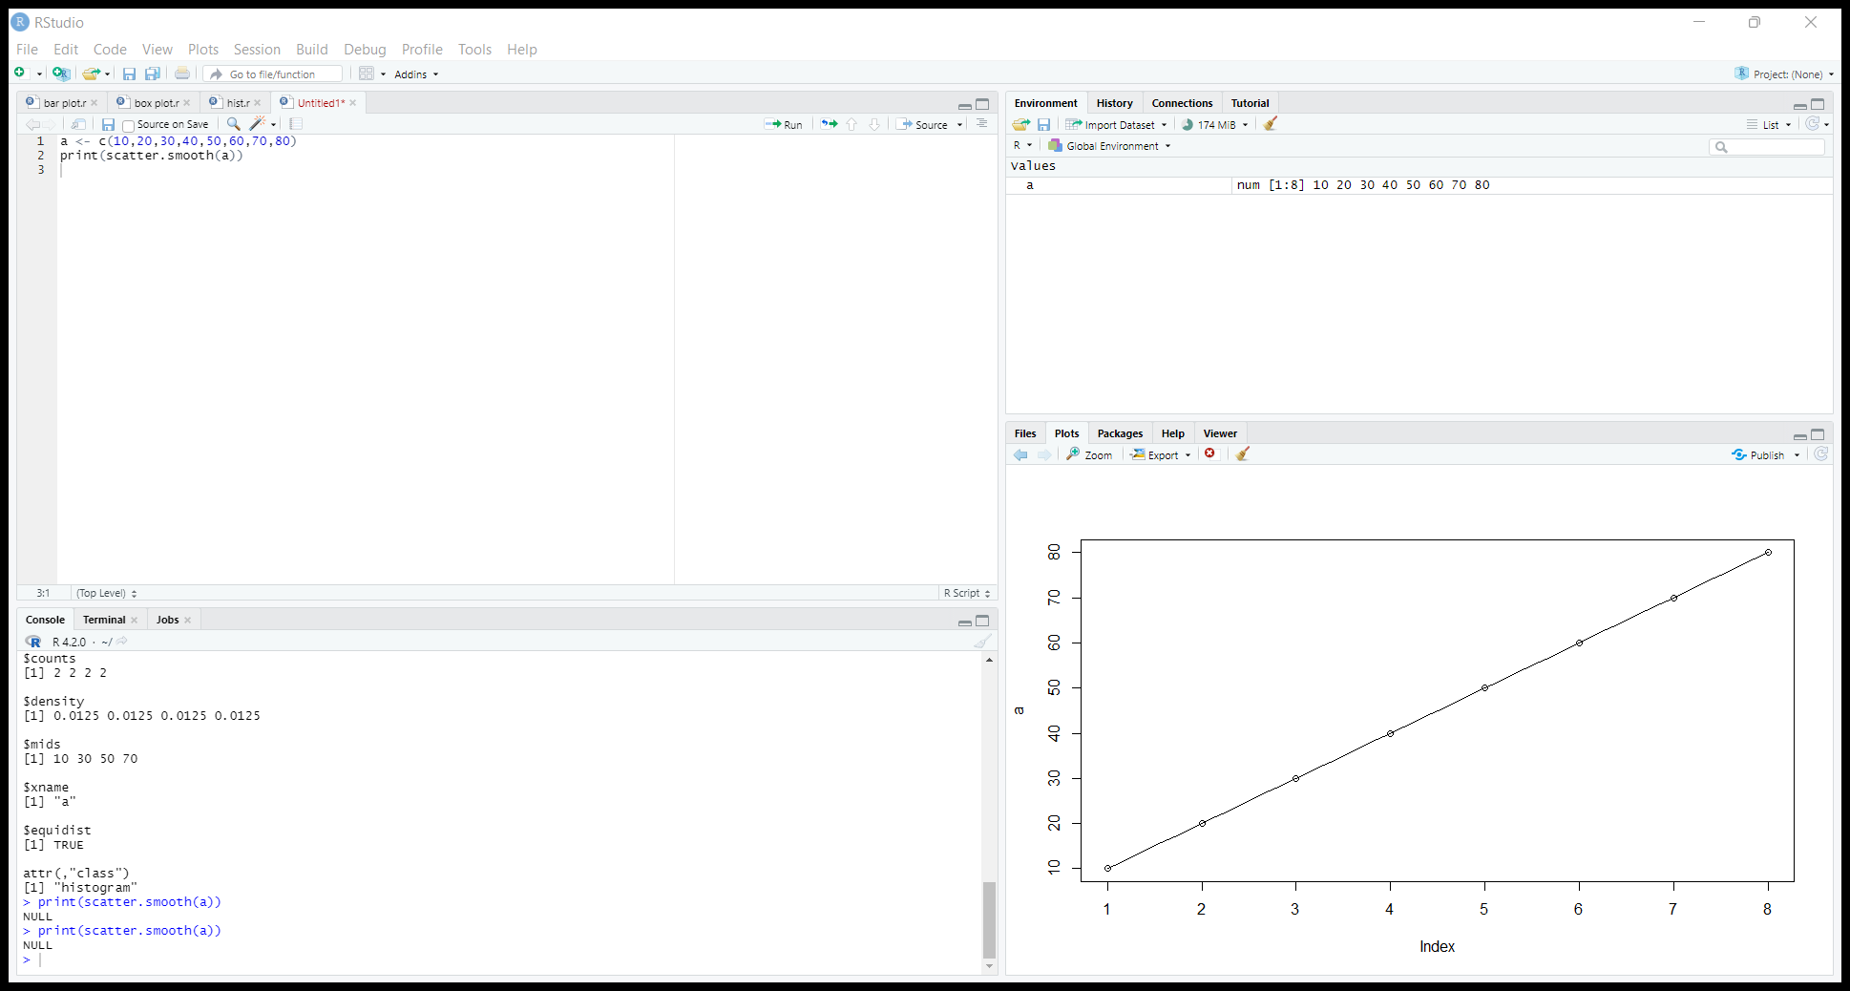

5)R-Program for Linear Regression:

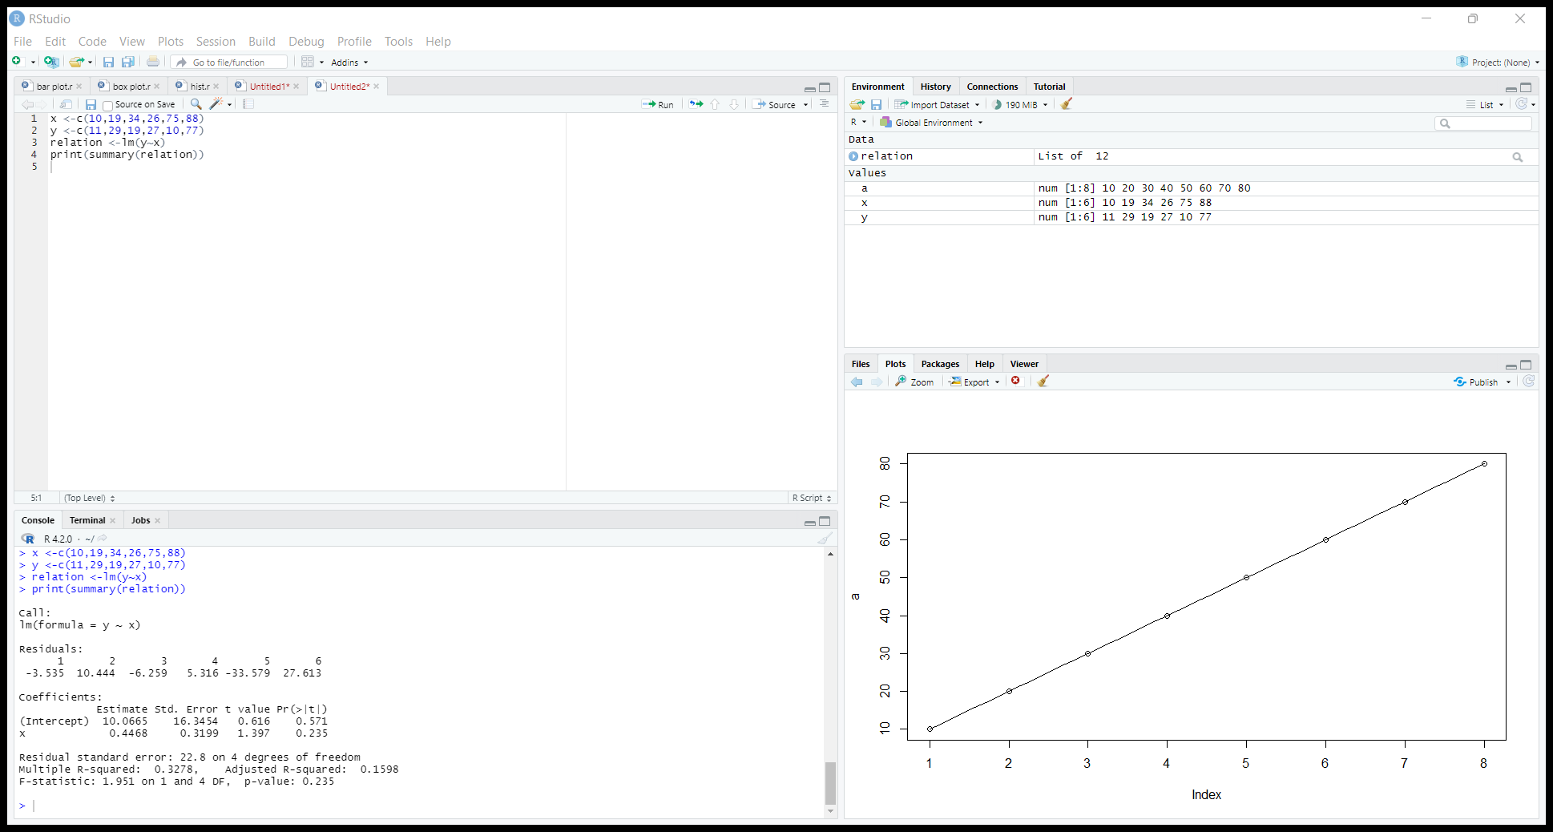

Output:

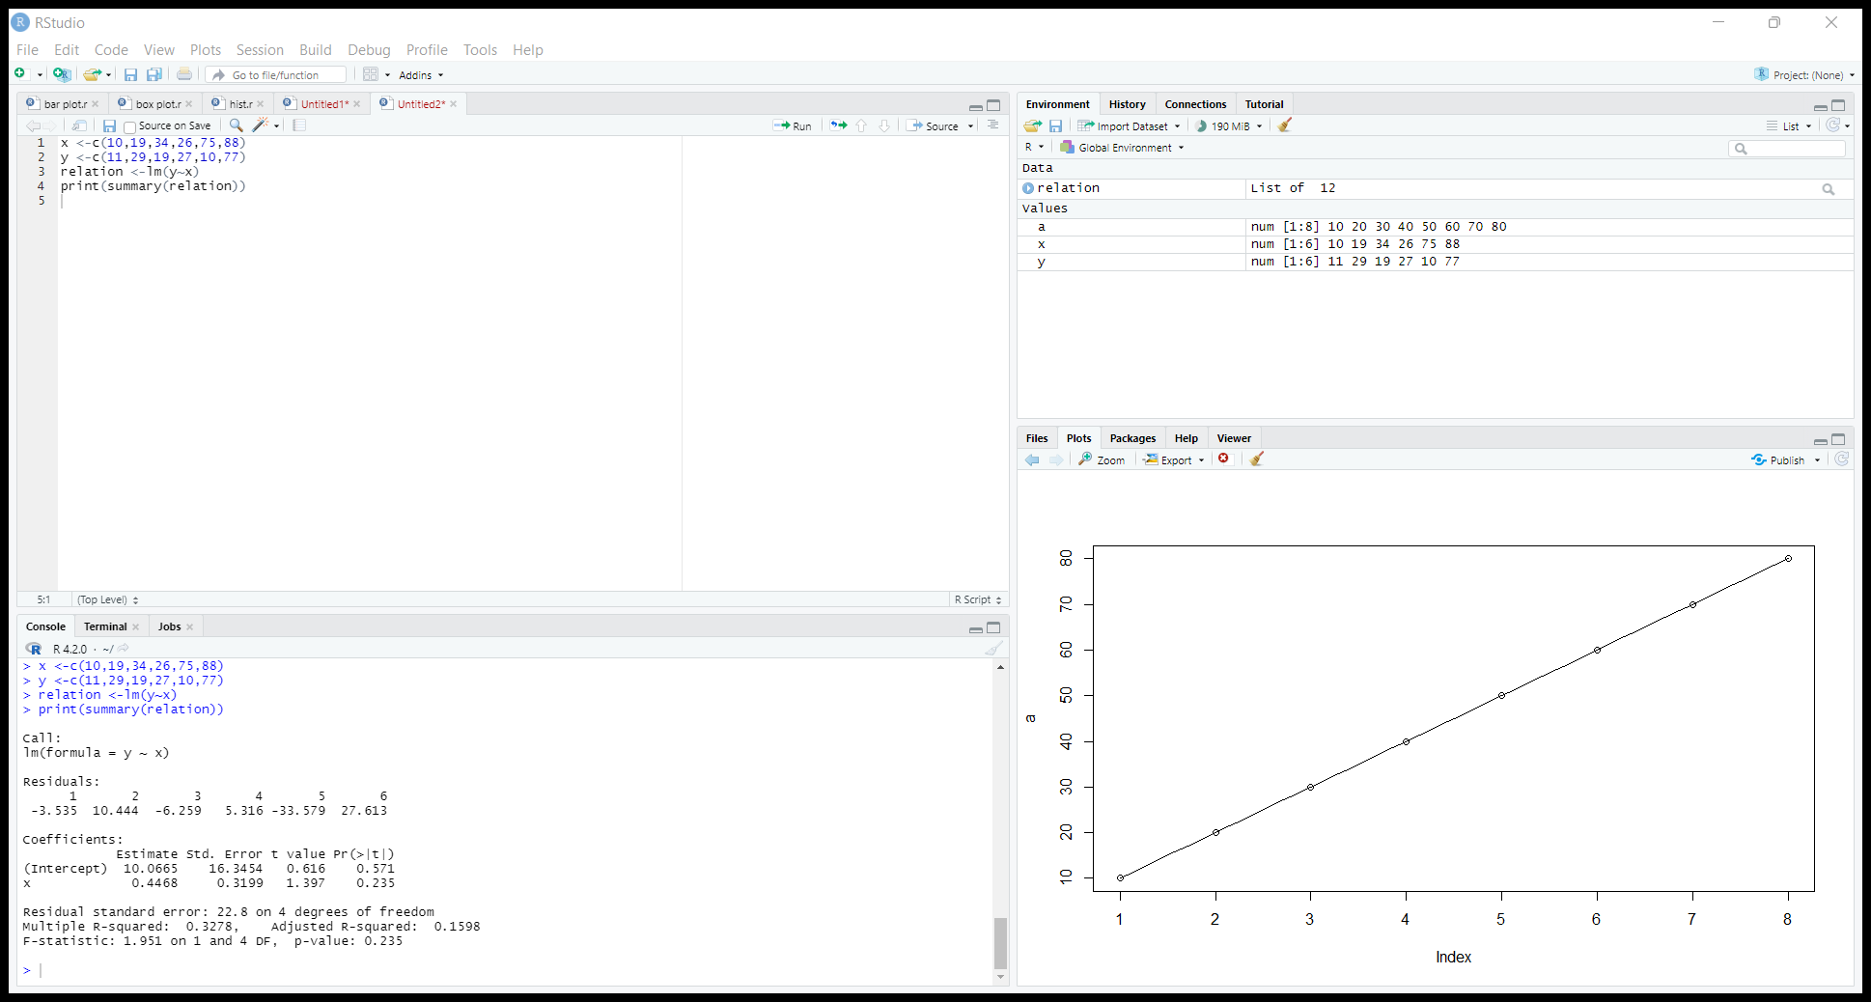

6)R-Program for Multiple Regression:

Program:

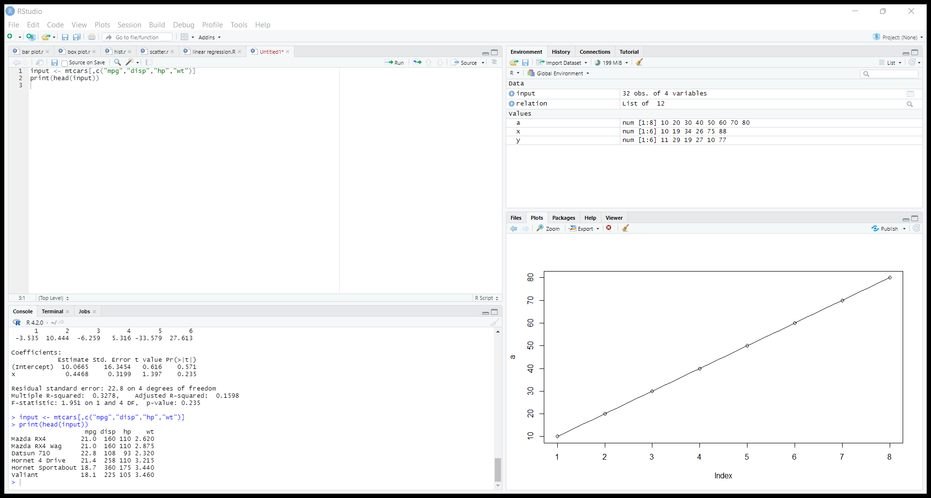

Output:

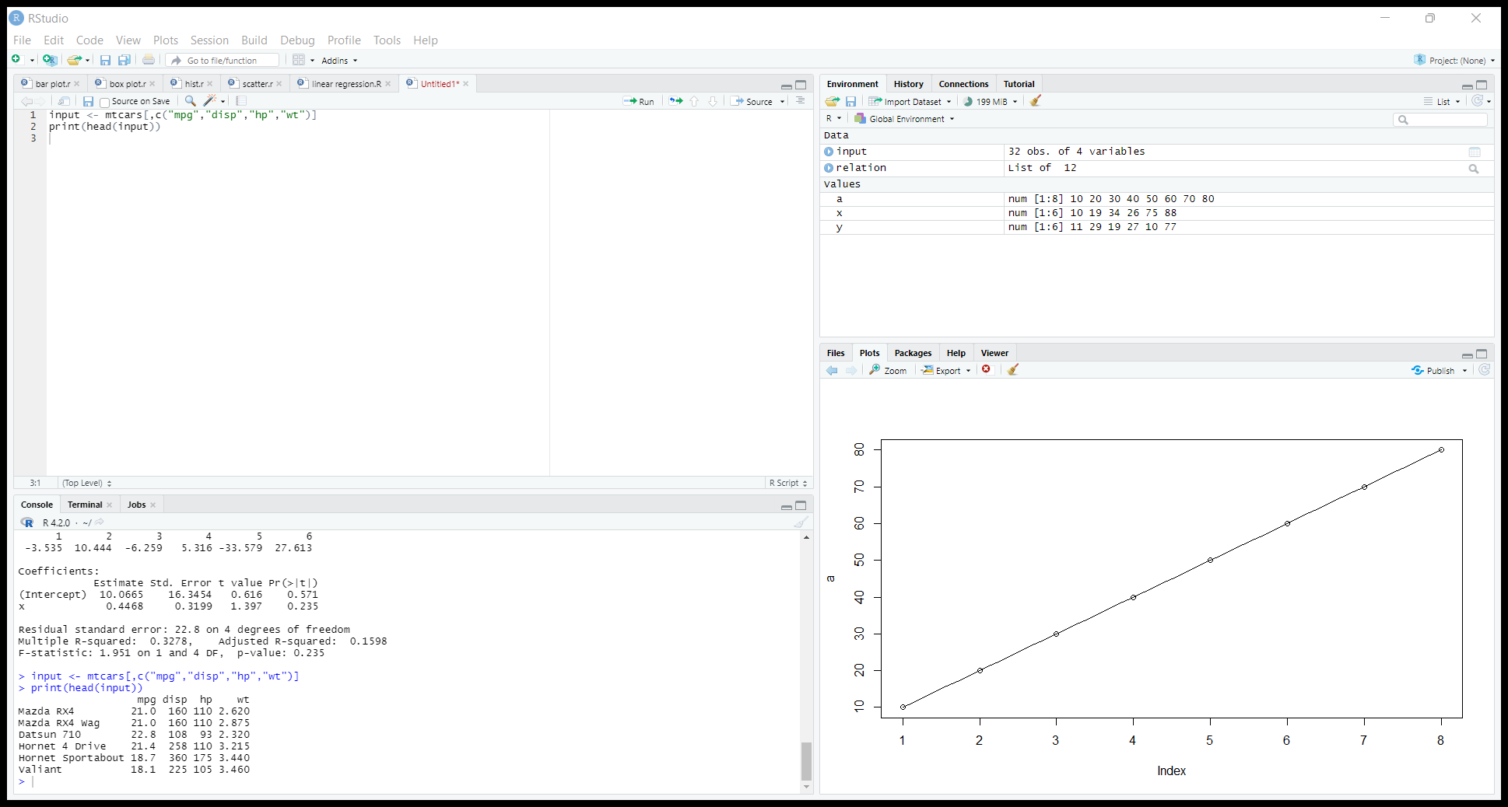

7)R-program for addition of two numbers

Program:

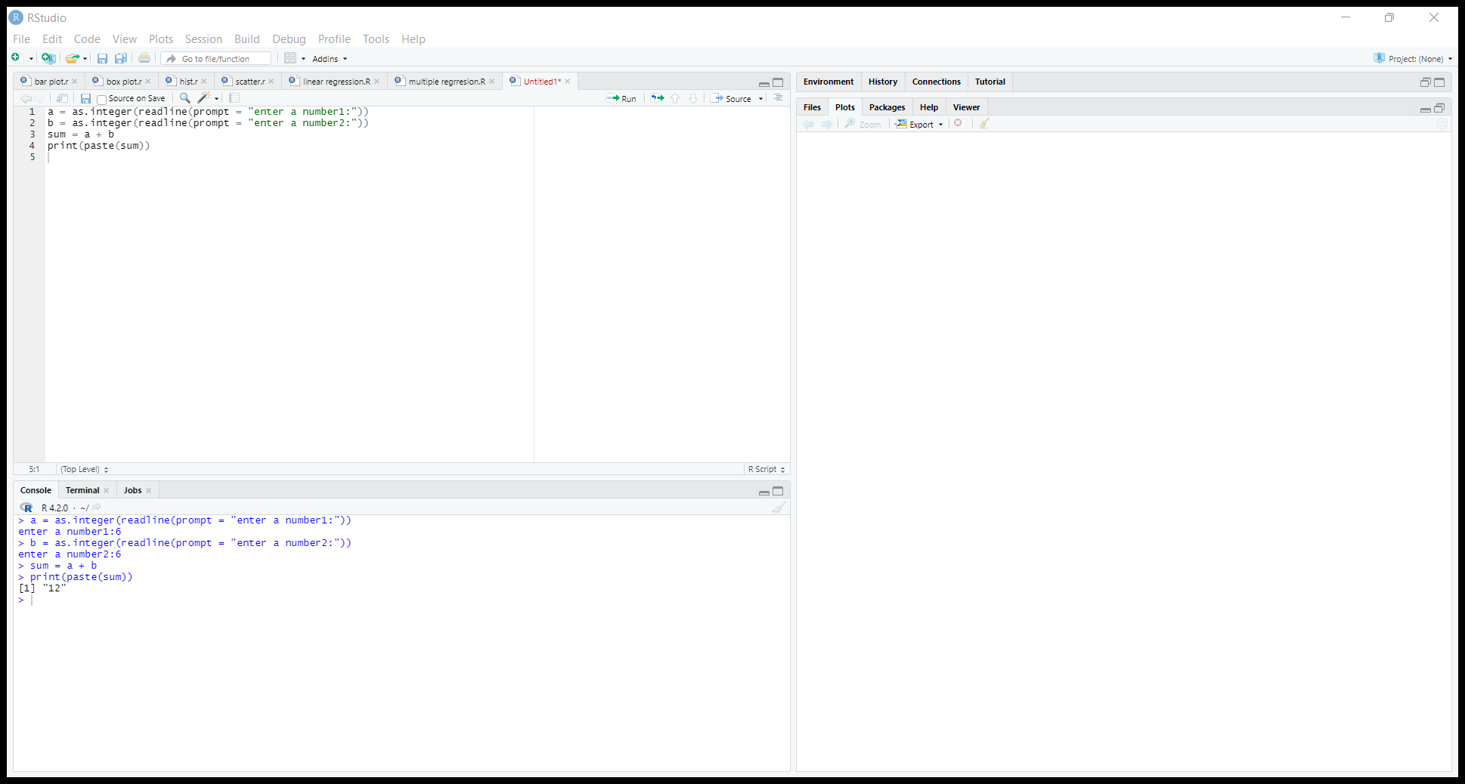

Output:



8)R-Program for subtraction of two numbers:

Program:

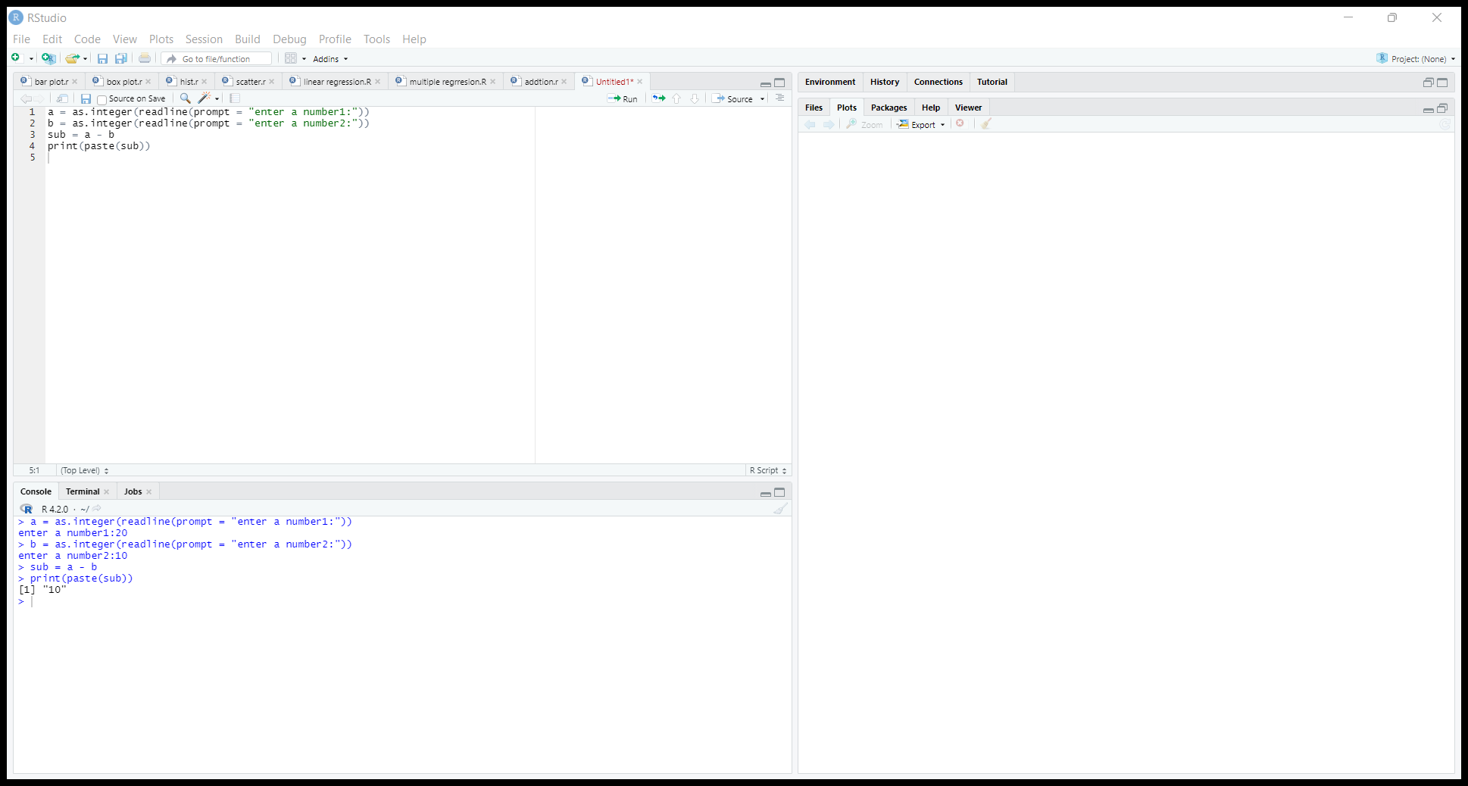

Output:



9)R-Program for multiplication of two numbers

Program:

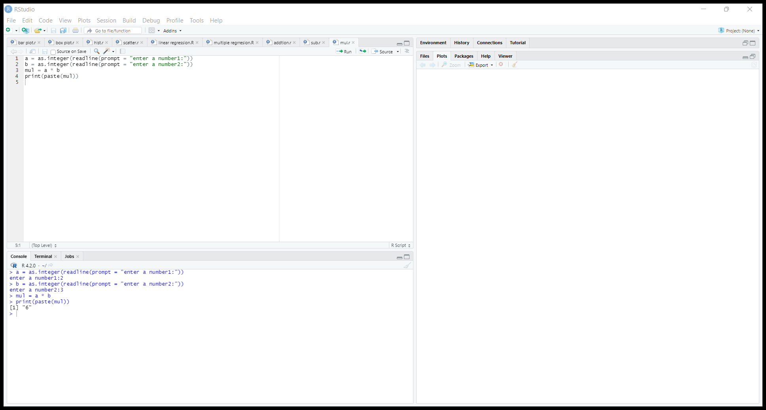

Output:

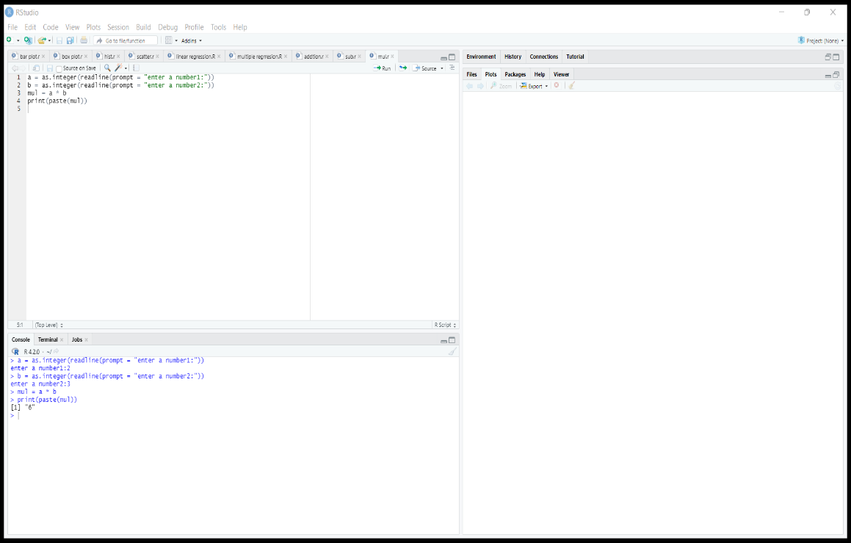

10)R-Program for Division of two number

Program:

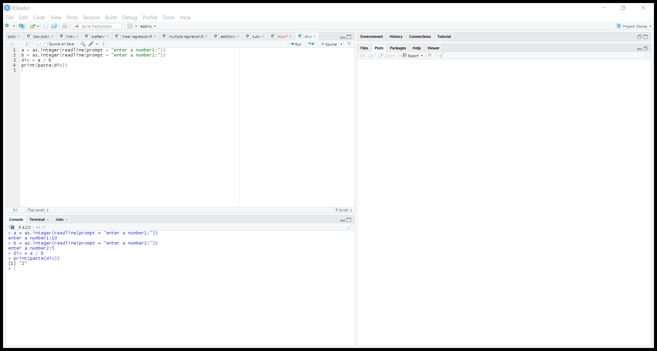

Output:



11)R-Program for mean of data

Program:

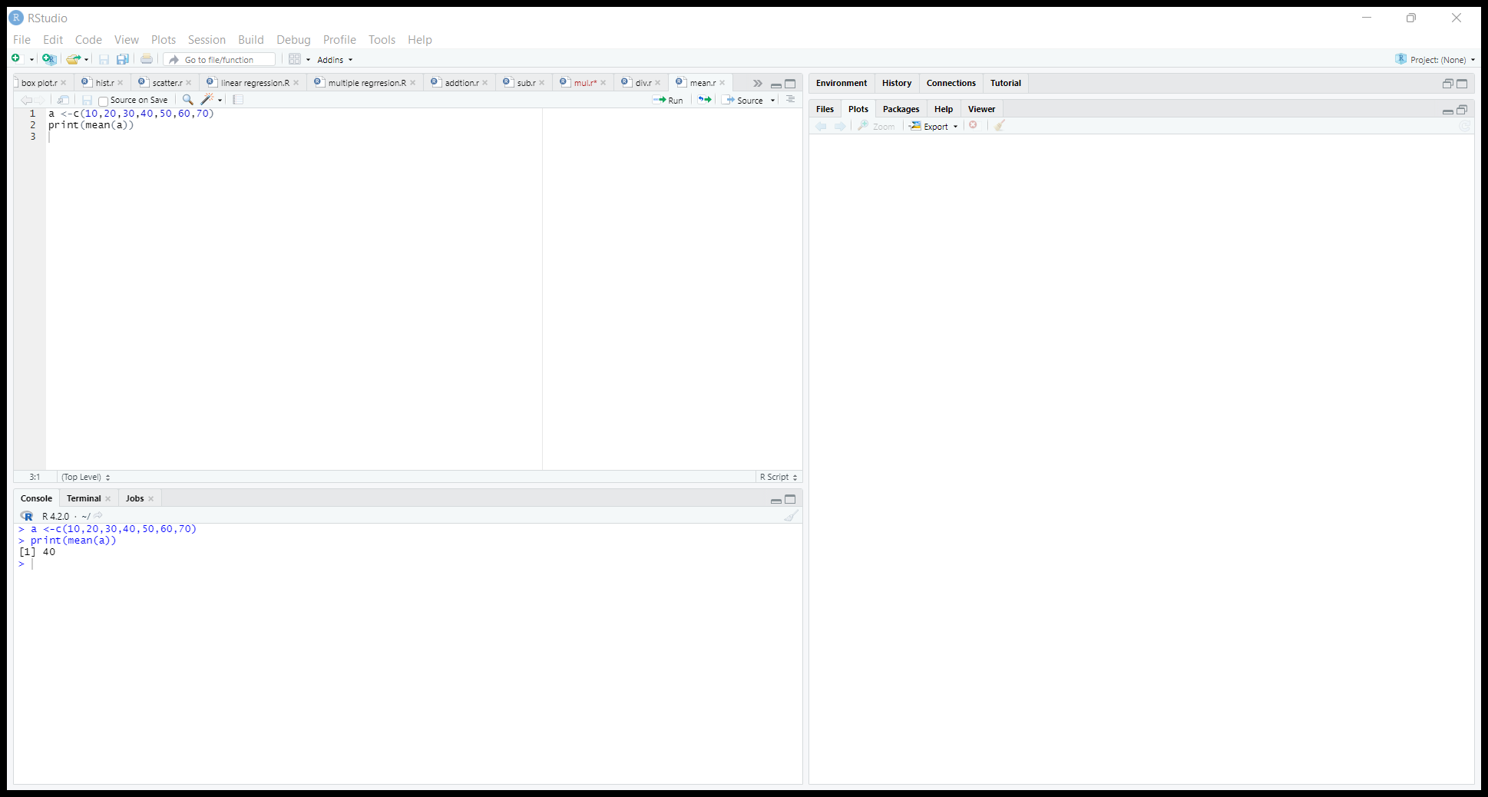

Output:



12)R-Program for median of data

Program:

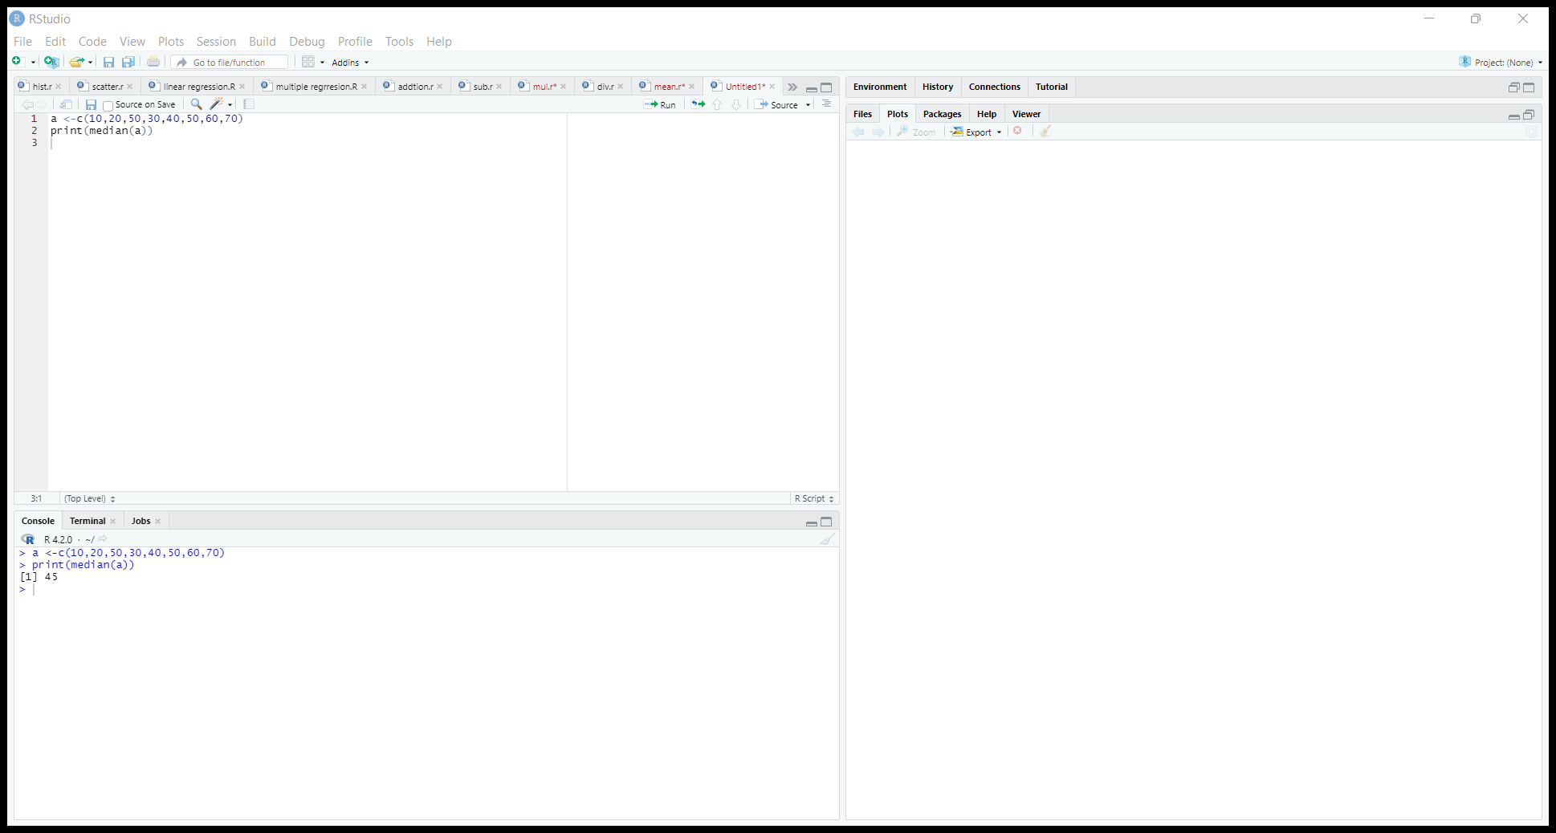

Output:



13)R-Program for Mode of data

Program:

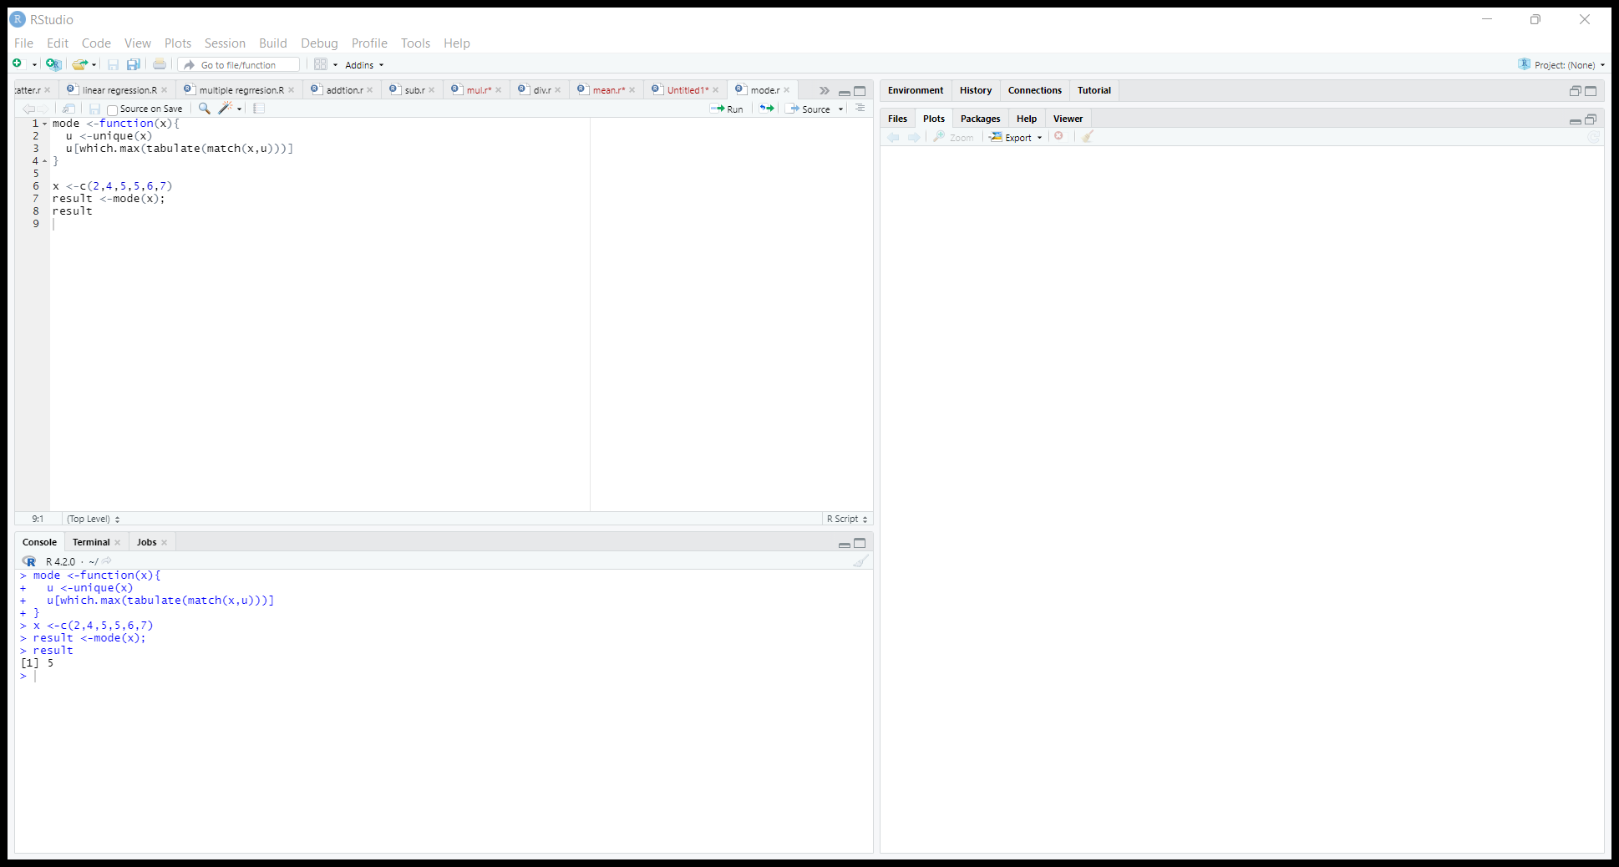

Output:



14)R-program for variance of data

Program:

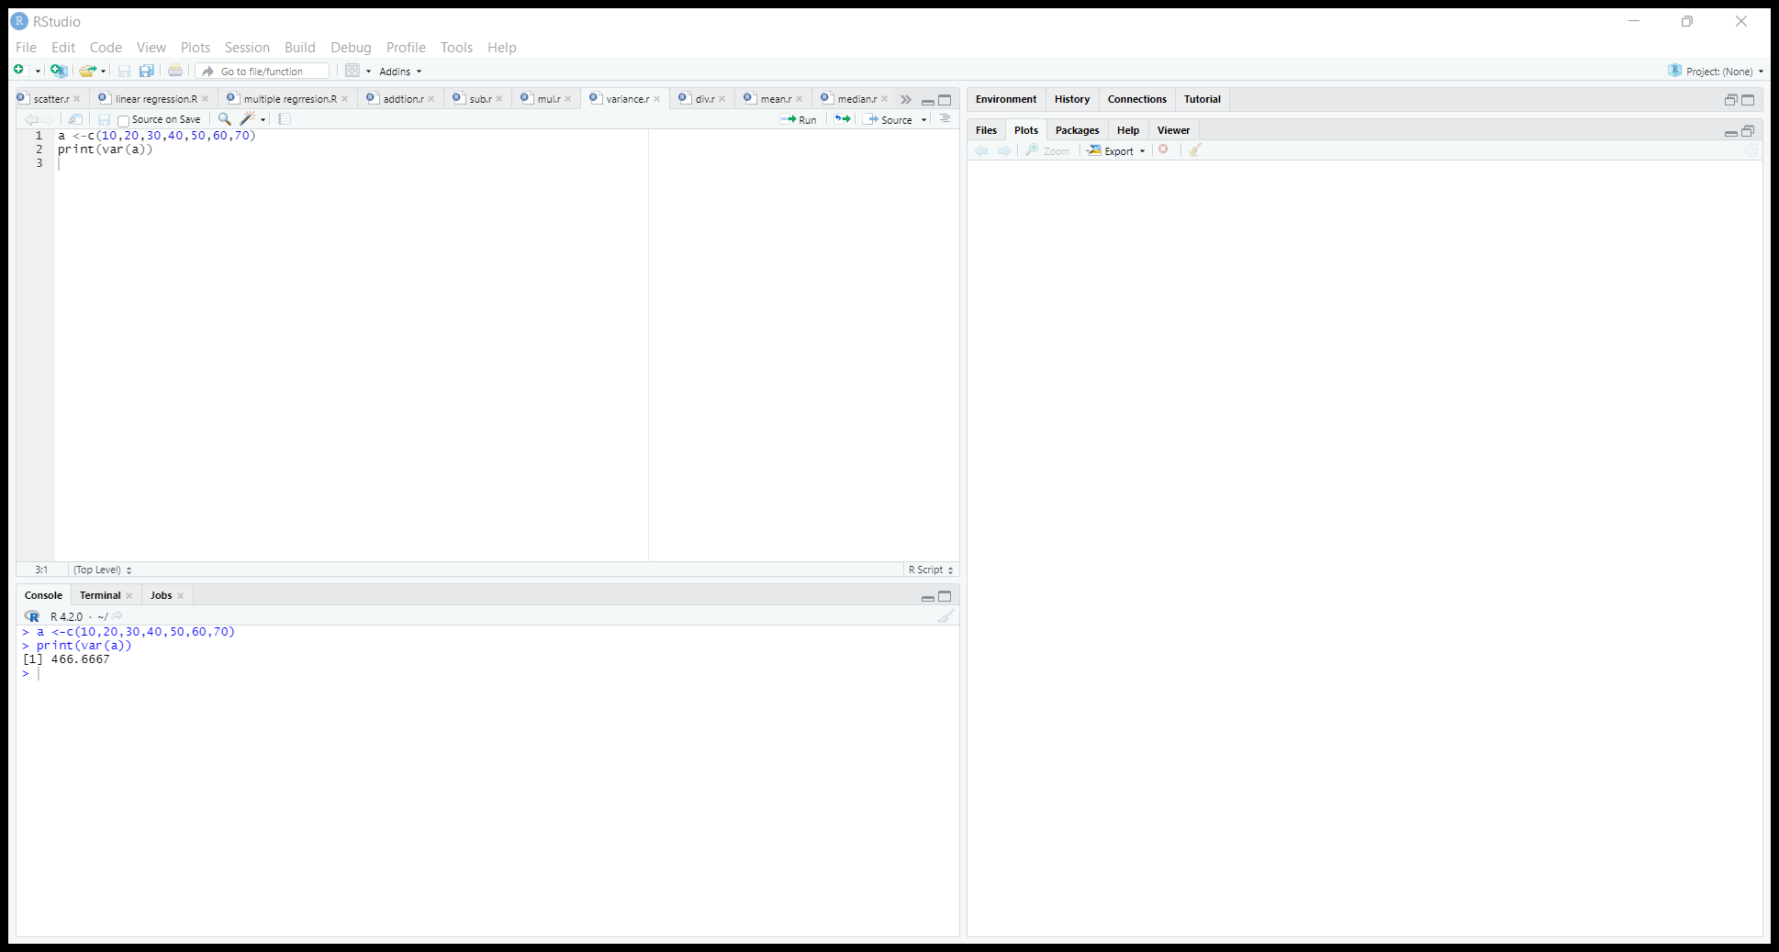

Output:



15)R-Program for Z-score normalization

Program:

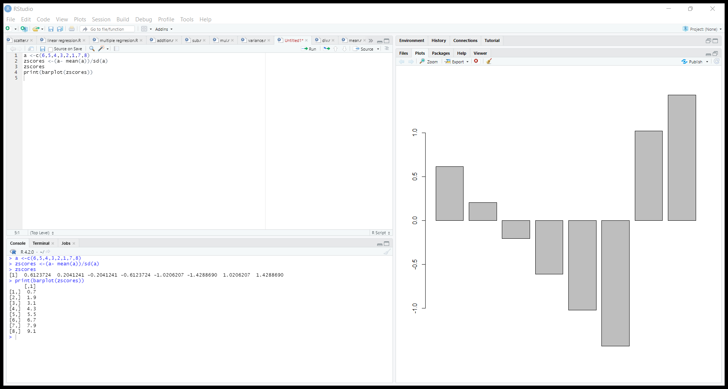

Output:



Bar plot:



16)R-Program for min-max normalization

Program:

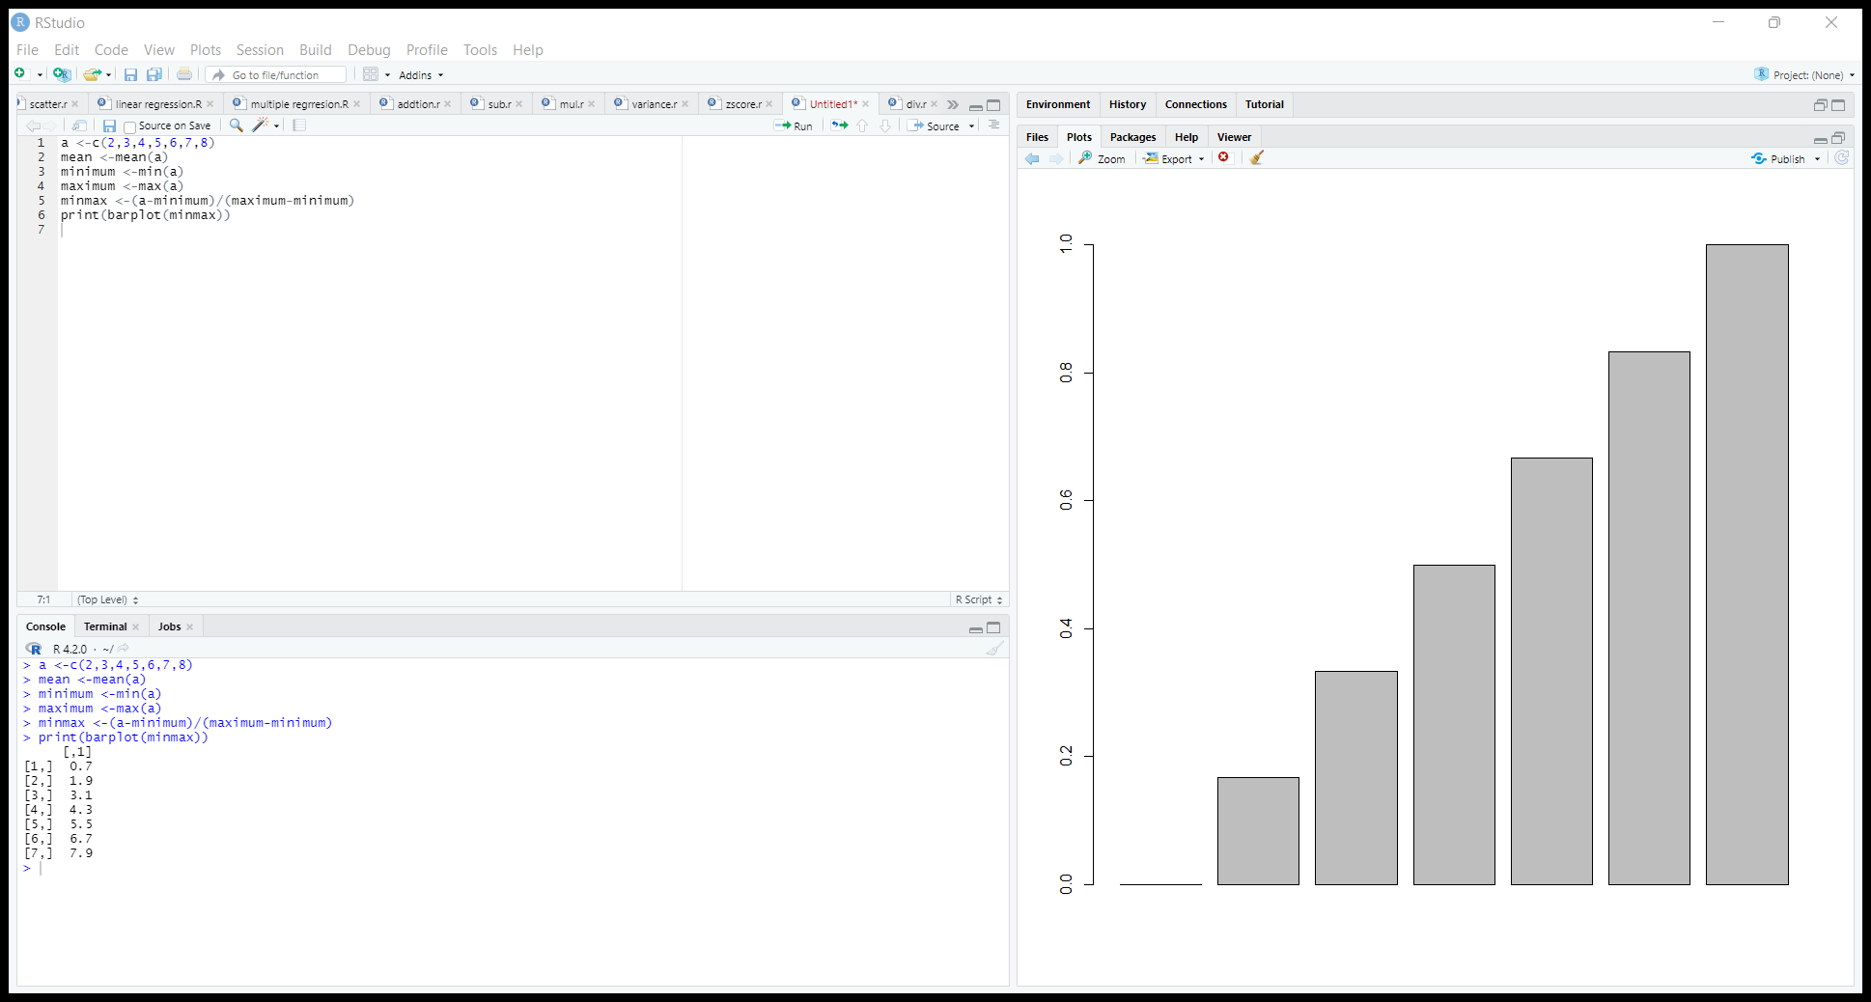

Output:



Bar plot:

